Southern Rockies Western Slope Agriculture

Identifying Drivers of Rangeland Production for Drought Planning on the Western Slope of the Southern Rockies

**Technical Report**

March 31, 2023

Adelaide Gonzalez (Project Lead)

Stephanie Willsey

Rachel Buchler

Max VanArnam

***Advisors:***

Nicholas Young, Colorado State University, Natural Resource Ecology Laboratory (Science Advisor)

Dr. Tony Vorster, Colorado State University, Natural Resource Ecology Laboratory (Science Advisor)

Dr. Paul Evangelista, Colorado State University, Natural Resource Ecology Laboratory (Science Advisor)

Dr. Catherine  Jarnevich, Colorado State University, Natural Resource Ecology Laboratory (Science Advisor)

Chris Choi, Colorado State University, Natural Resource Ecology Laboratory (Science Advisor)

***Fellow***

Sarah Hettema (Colorado – Fort Collins)

# 1. Abstract

Over the last decade, the southern Rocky Mountains of the United States experienced severe and variable drought. Local ranchers and landowners have reported strain on their operations, citing decreasing forage for their cattle and a need to adjust their business models. This study identified Major Land Resource Area-48 (MLRA-48) and northwestern Colorado as the key region for analysis. NASA DEVELOP partnered with the BLM Colorado River Field Office, Colorado State University Extension, USDA Forest Service, and the National Drought Mitigation Center to address concerns regarding the efficacy of remotely sensed rangeland production platforms and identify early warning climatic indicators of drought. The study identified two key platforms, The Rangeland Productivity Monitoring Service (RPMS) and Rangeland Analysis Platform (RAP), which use NASA Landsat 5 TM, Landsat 7 ETM+, Landsat 8 OLI, and Landsat 9 OLI-2 to estimate rangeland biomass. We regressed these with in situ biomass data to validate their efficacy and found that RAP was more effective than RPMS in estimating rangeland biomass, though it presents a tendency to overestimate. Our study performed a random forest analysis, comparing monthly RAP biomass estimates to a variety of climate variables, including mean precipitation, temperature, Palmer Drought Severity Index, snow water equivalent, snow persistence from Terra MODIS, wind speed and direction, and vapor pressure deficit. We determined that vapor pressure deficit and precipitation are key indicators in predicting forage production in MLRA-48. Our climate analysis provided our partners with greater understanding of the influence of various climate variables in determining rangeland production and allows them to assist land managers in drought mitigation.

**Key Terms**

remote sensing, rangeland production, drought, Landsat, MODIS, RAP, RPMS, early-warning climate indicators

# 2. Introduction

***2.1 Background Information***

The Rocky Mountains of the western United States are an iconic figurehead of vast mountain and rangeland ecosystems. Local ranchers often run their cattle on this region’s federal land during summer months, moving their stock to lower elevations in the winter (US Agricultural Handbook, 2022). With increasing global temperatures, rangeland ecosystems have experienced progressively more frequent and persistent drought (US Drought Monitor, n.d). In the Southwest Rockies and Colorado Plateau in particular, these dry intervals are characterized by reduced rainfall and increasing variability in the timing of precipitation (Zhang et al., 2021). With worsening drought conditions, ranchers have reported strain on their operations, citing decreasing forage production for their cattle and a need to adjust their business models, even considering abandoning their businesses altogether (Borden, 2020).

There are a variety of national and regional field-based measurements of rangeland biomass (Herrick et al., 2017, NRCS 2015). However, in situ data collection is inherently limited in geographic and temporal scale. As a result, rangeland scientists have turned to satellite and airborne remote sensing to analyze past data and project future changes in rangeland production (Jones et al., 2021, Jones et al., 2020, Smith et al., 2019, Ford et al., 2018). In order to validate remotely sensed data, regional (Jansen et al., 2018) and broader multiregional (Reeves et al., 2020) studies have evaluated the empirical relationship between remotely sensed and field data, allowing for better adaptive rangeland monitoring tools.

The Rangeland Analysis Platform (RAP) is one of the most prolific vegetation monitoring systems used by US rangeland managers. RAP uses the Normalized Difference Vegetation Index (NDVI), a remotely sensed proxy for primary vegetative productivity, as well as plant functional types (PFTs), to characterize annual rangeland production across the United States (Jones et al. 2021). RAP is available at 30-meter resolution for 16- day and annual timescales and represents newly accumulated herbaceous above ground biomass (HAGB) (Jones et al. 2021). Another commonly used rangeland monitoring service is the Rangeland Productivity Monitoring Service (RPMS). This data set maps annual total primary production for US rangelands at 30- and 250-meter resolutions using NDVI and is processed using the Rangeland Vegetation Simulator (RVS).

While both data sets have proven useful to rangeland managers, these models have not been specifically validated with field data for the Southern Rockies. In a study conducted by Jones et al. (2021), RAP and RPMS data were validated against field data. The Jones et al. (2021) study was notably broad in its geographic scale and did not validate their model with data past 2019. Therefore, there is still uncertainty as to the efficacy of these platforms in evaluating rangeland production, particularly in the highly climatically variable southern Rocky Mountains.

The project limited its study area to Major Land Resource Area (MLRA) 48 and the northwestern corner of Colorado. Major Land Resource Area 48 spans the western slopes of the southern Rocky Mountains, encompassing 50,921 square miles over four states. The majority of MLRA-48 lies in Colorado, with smaller portions in New Mexico, Utah, and Wyoming, and is broken up into two sections, MLRA-48A and MLRA-48B. This region is characterized by a highly heterogenous climate, with altitudes ranging from 6,500 to 14,400 feet and annual precipitation of 7-73 inches. Land uses for this MLRA include grazing, recreation, forestry, and irrigated farming (USDA Agricultural Handbook. 2022).

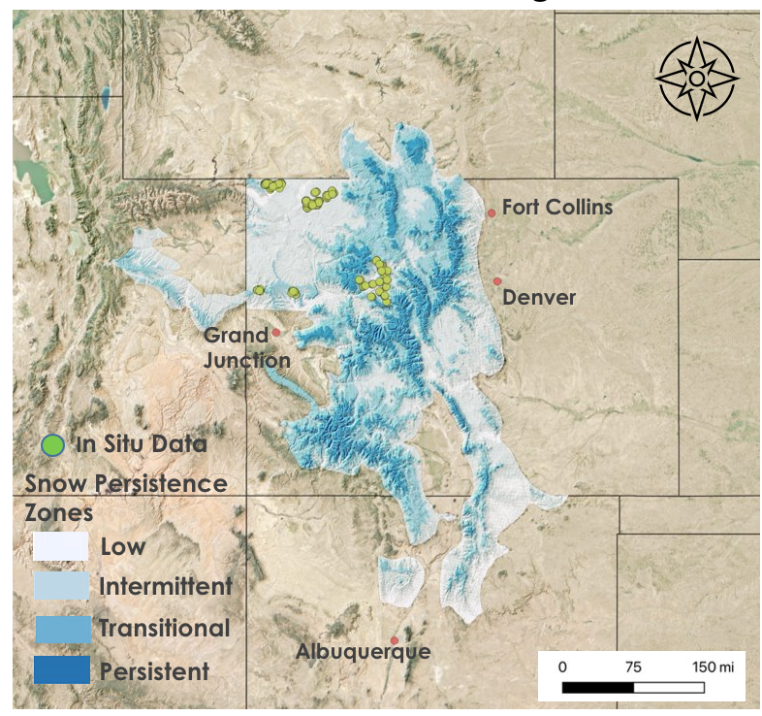

*Figure 1.* Study area depicting MLRA-48 and northwestern Colorado. The study area is delineated into low (white), intermittent (light blue), transitional (medium blue), and persistent (dark blue) snow zones, which reflect percentage of annual snow persistence (Table 3) derived from snow persistence data from 2001-2020 provided by the USGS and projected in QGIS. Data was accessed on February 15, 2023. Hillshade is derived from the USGS 3DEP Elevation dataset. In situ data points sourced from CSU Extension are shown in green/yellow circles.

***2.2 Project Partners & Objectives***

Rangeland managers face uncertainty about the amount of forage that will be available for their livestock. Ranchers in this region have become increasingly invested in drought forecasting, seeking a scientific perspective to make stocking decisions and minimize financial loss. The US Forest Service (USFS), the Bureau of Land Management (BLM), Colorado State University (CSU), and the National Drought Mitigation Center (NDMC) work with rangeland managers on the western slope of the southern Rocky Mountains. While these organizations focus primarily on field data collection, they have expressed interest in the reliability of certain rangeland remote sensing platforms. Additionally, these organizations continue to search for early warning indicators of regional drought. Our partners are familiar with remote sensing and NASA Earth observations but have only implemented them into their analyses in a limited capacity. This project exposed our partners to the capabilities of using NASA Earth observations for rangeland monitoring.

To support the partners’ rangeland monitoring actions, we investigated the use of remote sensing to measure rangeland biomass and identify meteorological variables capable of indicating drought. Our objectives were to (1) produce ground truth rangeland models that quantify the reliability of the RAP and RPMS remote sensing products, and to (2) create a forage production analysis of the relationship between production and multiple meteorological factors in the region. With a better understanding of the reliability of RAP and RPMS data, our partners can make better informed decisions about the inclusion of these remote sensing products in their work. Additionally, the analysis of the relationship between climatic variables and forage production will support the partners’ efforts to forecast droughts in the region.

# 3. Methodology

***3.1 Data Acquisition***

***3.1.1 In Situ Data***

Our partners at Colorado State University Extension provided in situ biomass data from 5 sites across Colorado, measuring herbaceous and total production. The field team collected biomass samples in the summers of 2013, 2014, 2015, and 2022 (Table 1). These field data were collected using methods adapted from the National Range and Pasture Handbook, and National Resource Inventory sampling methods. Data collected from 2013 to 2015 were clipped in 40cm-by-40cm quadrants with 2 quadrants per transect line resulting in 10 clipped quadrants per plot. Clipping data collected in 2022 were sampled from 5 quadrants per plot, and quadrants measured 4.8 square foot circular plots. The CSU team aggregated the final data to the plot level and measured it in pounds per acre (lbs/acre).

Table 1. *In situ data sources used in analysis*

|  |  |  |  |
| --- | --- | --- | --- |
| **Platform/Sensor** | **Data Product** | **Dates** | **Acquisition Method** |
| CSU Extension | Herbaceous production and total production clipping data | 2013, 2014, 2015 and 2022 | Our partners provided plot level clipping data in  Excel format. |

***3.1.2 Remote Sensing Rangeland Data***

This study used the RPMS and RAP remote sensing products to map rangeland production. RAP uses Landsat 5 Thematic Mapper (TM), 7 Enhanced Thematic Mapper Plus (ETM+), 8 Operational Land Imager (OLI) and 9 OLI-2 to calculate annual herbaceous production in lbs/acre at a 30-meter spatial resolution (Jones et al. 2021). RPMS also uses Landsat 5 TM, 7 ETM+, 8 OLI and 9 OLI-2 but calculates annual total production in lbs/acre at 30-m spatial resolution (Table 2.).

Using GEE and the code provided on the RAP website (Rangeland Analysis Platform 2023), our study exported RAP annual herbaceous production data from 2013, 2014, and 2015. This code sources from the RAP gridmet-MAT [and npp-partitioned-v3 image collections and](http://www.fuelcast.net) w[e masked all land cover types except for annual and perennial grass and forb growth, to exclude shrubs, trees, and bare ground as well as irrigated agricultural land. The resulting data represent annual production of grasses and forbs. RPMS uses Google Earth Engine’s Thematic Mapper data suite to generate the Normalized Difference Vegetation Index (NDVI) from Landsat imagery and convert these data into annual total production (lbs/acre) using the Rangeland Vegetation Simulator (RVS). We downloaded RPMS data for 2013, 2014, 2015 and 2022 from the RPMS website.](http://www.fuelcast.net)

In order to constrain our study points to unforested rangeland, our team downloaded the LANDFIRE forest canopy cover data set from the USDA Forest Service and U.S. Department of the Interior cosponsored LANDFIRE website. These data use Landsat-derived NDVI to describe percent tree canopy within a 30-m pixel and allowed us to define the canopy cover at each of our in situ locations.

***3.1.3 Climate Data***

This study examined a wide variety of possible early warning climate indicators of rangeland production. These included precipitation, mean temperature, vapor pressure deficit maximum and minimum, soil moisture, Palmer Drought Severity Index, and wind speed data as climatic indicators of rangeland production (Table 2). We accessed precipitation, mean temperature and vapor pressure deficit data using the Parameter-elevation Regressions on Independent Slopes Model (PRISM) Earth Engine Catalog developed by Oregon State University’s PRISM Climate Group (Table 2, Table A1.). We acquired the soil moisture data from the NASA-USDA SMAP data set and accessed drought and wind data through the Gridded Surface Meteorological (GRIDMET) database (Table 2).

Table 2. *Remote sensing and climate data sources included in analysis*

|  |  |  |  |  |
| --- | --- | --- | --- | --- |
| **Platform/Sensor** | **Data Product** | **Spatial Resolution** | **Dates** | **Acquisition Method** |
| Landsat 5 TM,  Landsat 7 ETM+,  Landsat 8 OLI,  Landsat 9 OLI-2 | RAP and RPMS forage production, LANDFIRE forest canopy cover | 30-m | 1984 – present (RAP, RPMS)  2004 – present (LANDFIRE) | Annual biomass data accessed with RAP Google Earth Engine tool and RPMS download link. LANDFIRE data downloaded from LANDFIRE website |
| MODIS | Contiguous US Snow Persistence and Trends | 500-m | 2001 - 2022 | Data were downloaded from USGS’s Science Base catalog |
| PRISM | Precipitation, Temperature, Vapor Pressure Deficit, PDSI, Wind Velocity | 4638.3-m | 1980 - present | Data were downloaded from Oregon State University’s PRISM Climate Group and GRIDMET GEE data set |
| Daymet | Snow Water Equivalent | 1000-m | 1980 - 2021 | Data were downloaded from NASA/Oak Ridge National Laboratory Daymet v4 GEE data set |

To aid in our analysis, we divided our study area into classified snow zone subregions using Snow Persistence data from the US Geological Survey (USGS, n.d.). This data set uses Terra MODIS and contains the percent yearly snow presence across a 500-meter spatial resolution in the contiguous United States from 2001-2020 (Table 2). 77.4% of MLRA-48 falls into the intermittent and transitional snow zones, with the remaining high altitude and outlying lowlands regions falling into the low and persistent ranges.

***3.2 Data Processing***

This study used Google Earth Engine to import and clip annual RAP and RPMS raster assets. Our team then extracted raster values from both RAP and RPMS at the corresponding latitude and longitude of each in situ data point. To divide our study area into snow zones, our team classified the 500 m resolution USGS snow persistence data into four snow zones following the classification scheme established in Hammond et al., 2018. (Table 3).

Table 3. *Snow zones as defined by Hammond et al., 2018.*

|  |  |  |  |
| --- | --- | --- | --- |
| **Snow zone** | **Percent Snow Persistence** | **Number of Herbaceous Production Field Sites** | **Number of Total Production Field Sites** |
| **Low (1)** | 0-25% | 4 | 0 |
| **Intermittent (2)** | 25-50% | 84 | 46 |
| **Transitional (3)** | 50-75% | 41 | 41 |
| **Persistent (4)** | 75-100% | 0 | 0 |

Our study also constrained our sampling to non-forested pixels. To accomplish this, we imported 2020 LANDFIRE canopy cover raster data into ArcGIS Pro and projected our in situ data points over the canopy cover data set. We extracted cover data for each in situ point and exported these values into Microsoft Excel. Our study established a threshold of 10% maximum forested canopy cover and excluded data points that exceeded this threshold.

To prepare data for the climate model, our team imported our study area shape file, then clipped out irrigated ag land and open water in ArcGIS Pro using the National Land Cover Database (NLCD). Then using the LANDFIRE canopy cover data set, we clipped out regions with a canopy cover exceeding 10%. After these clipping steps, we generated 1500 random points with a 5km minimum distance to use as sampling locations for our climate data.

To prepare climate data for sampling, our team used GEE to convert all climate data into monthly averages with the exception of precipitation, which was converted into a monthly total (Table A1). Following the same raster value extraction process as phase one, we pulled climate data from the raster layers at the locations of our randomly generated points for each year from 1992-2021. We repeated this methodology with LANDFIRE Existing Vegetation Type (EVT) and snow zones as categorical variables, though only once, as we assumed that vegetation type and snow zone were consistent across the study period.

The 1500 climate data values for each month of each year were then imported into R studio for processing. Using the packages diplyr and tidyr, our team converted the monthly climate data into seasonal mean values, with the exception of precipitation which was summed to seasonal total values. For a summer growing season, the previous summer was considered (preceding June, July, August), previous fall (preceding September, October, November), winter (preceding December, January, February), and spring (preceding March, April, May), and the current summer (current June, July, August) season for each climate variable. These data were then merged with corresponding yearly RAP values and land cover type data and then sorted into the same snow zones used in phase one. We performed this processing for each year from 1992-2021 and then bound all years using the diplyr ‘bind’ function (Wickham, 2023).

***3.3 Data Analysis***

Using R Studio version 1.1.447, our team ran a linear regression analysis of in situ data points against remotely sensed rangeland biomass data. With points divided by snow zone (Table 3), we regressed RAP data against in situ herbaceous biomass data and RPMS total production data against total production in situ data. To gain a deeper understanding of RAP and RPMS’s reliability, our team performed linear regressions across each individual snow zone. This analysis generated R2 and p-values, as well as fitted and residual values that were used to calculate the root mean square error (RMSE) and mean bias of each relationship. Our team plotted results using the R package ggplot2 with a line of best fit and a 1:1 line (Wickham, 2016).

Our study grouped yearly climate data and seasonal variables than ran it through the “ranger” random forest model, where seasonal variables were ranked in their ability to predict the associated year’s summer forage production, represented by RAP biomass (Wright, 2017). We repeated this process and ran another climate model including EVT as a categorical variable. We evaluated the significance of our two climate models using R2, RMSE, mean bias, and the coefficient of variation.

# 4. Results & Discussion

***4.1 Phase One Results***

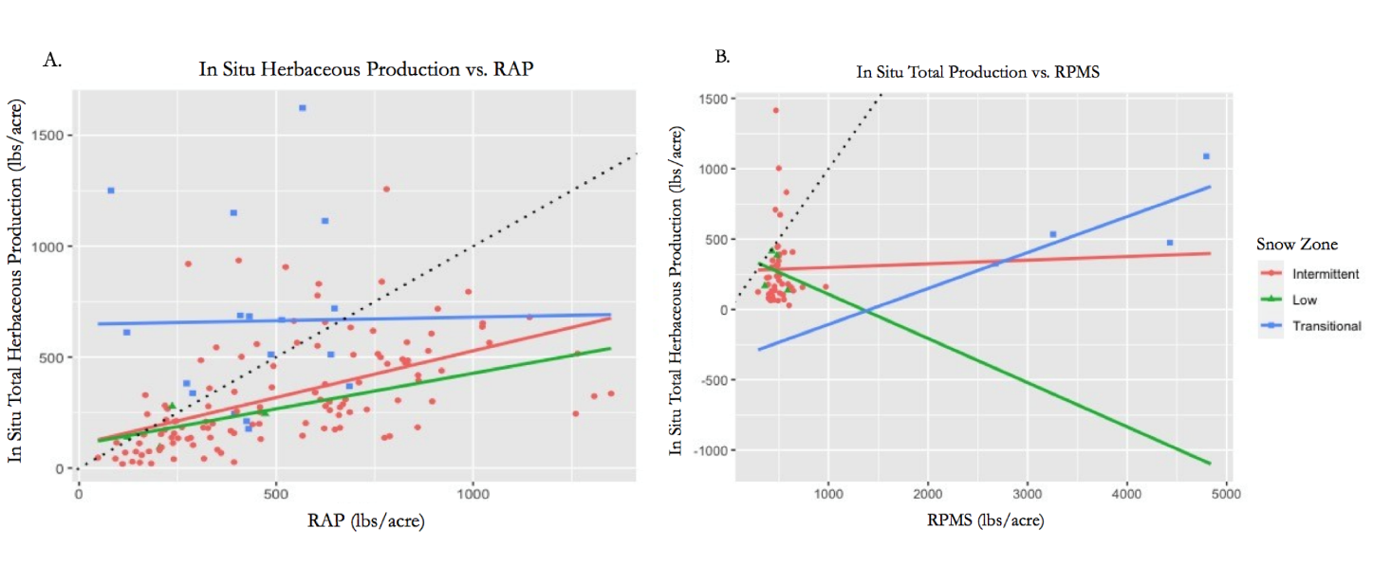*Figure 2.* (A.) In situ herbaceous rangeland production plotted against RAP production estimates (lbs/acre) and (B.) in situ total production plotted against RPMS total production estimates (lbs/acre) for 3 snow zones: low (green line, triangles), intermittent (red line, circles), and transitional (blue line, squares) with lines of best fit and a 1:1 line (black dotted).

Only four in situ data points were measured in the low snow zone, making the accuracy of the regression dubious. The linear regression run comparing remotely sensed and in situ herbaceous biomass produces an R2 value of 0.3084, indicating that 30.84% of RAP values can be explained by in situ herbaceous biomass data (Table 4). A low mean bias of 62.33 suggests that in the low snow zone, RAP consistently overpredicts in situ biomass. RPMS overpredicts at almost double that amount, with an RMSE of 122.167. High mean biases of -189.75 and -275.5 exhibit additional evidence of overprediction for RAP and RPMS, respectively. These statistics indicate that RAP outperforms RPMS in predicting in situ biomass within the low snow zone.

Table 4. *Snow Zone 1 (Low)*

|  |  |  |  |  |
| --- | --- | --- | --- | --- |
|  | **R2 (%)** | **P-value** | **RMSE** | **Mean Bias (%)** |
| **RAP** | 30.84 | 0.445 | 62.33 | -189.75 |
| **RPMS** | 4.43 | 0.790 | 122.17 | -275.50 |

Within snow zone two, the herbaceous biomass linear model outputs an R2 value of 0.2745 (Table 5). This demonstrates that 27.45% of RAP data are explained by the in situ total herbaceous biomass data. An RPMS R2 value of 0.0001065 suggests that in this instance, RAP far outperforms RPMS in predicting observed biomass data. The herbaceous biomass linear model performs best in the intermittent snow zone. This may be due to uneven sampling, with 119 of 139 in situ data points categorized as having intermittent snow persistence. The P-value for the RAP herbaceous biomass regression is well below 0.05, indicating that there is a significant statistical relationship between the in situ and remotely sensed data. The P-value for RPMS is 0.9457, above the 0.05 threshold, indicating there is no significant statistical relationship between the in situ and remotely sensed data. The RMSE values for both RAP and RPMS indicate that the remote sensing products struggle to produce precise data. Additional evidence of overprediction across remotely sensed data can be seen in mean bias values of -329.7815 and -285.5217 from RAP and RPMS, respectively. Overall, these statistics suggest that RAP outperforms RPMS in predicting in situ biomass in the intermittent snow zone.

Table 5. *Snow Zone 2 (Intermittent)*

|  |  |  |  |  |
| --- | --- | --- | --- | --- |
|  | **R2 (%)** | **P-value** | **RMSE** | **Mean Bias (%)** |
| **RAP** | 27.45 | <0.001 | 204.16 | -329.78 |
| **RPMS** | 0.01 | 0.946 | 264.94 | -285.52 |

Within the RAP linear model in the transitional snow zone, a low R2 value demonstrates no significant statistical relationship between the remotely sensed data and its corresponding in situ measurements. An RMSE of 388.24 demonstrates that RAP substantially overpredicts in this snow zone (Table 6). After excluding forested samples, only 4 data points remained of in situ total production data to regress against RPMS. The resulting statistical analysis yielded a comparatively high R2 value of 0.5754 and a p value of 0.2414. An RMSE of 188.299 and mean bias of –606 indicates that RPMS overpredicts in situ total biomass. These statistics indicate that RPMS outperforms RAP in predicting in situ biomass in the transitional snow zone, though the small sample size of RPMS does not allow for a fully robust analysis.

Table 6. *Snow Zone 3 (Transitional)*

|  |  |  |  |  |
| --- | --- | --- | --- | --- |
|  | **R2 (%)** | **P-value** | **RMSE** | **Mean Bias (%)** |
| **RAP** | 0.51 | 0.793 | 388.63 | -633.94 |
| **RPMS** | 57.54 | 0.241 | 188.30 | -606.00 |

***4.2 Phase Two Results***

***4.2.1 Model Performance***

|  |  |
| --- | --- |
|  |  |
| *Figure 3.* Predicted vs. observed values (purple circles) for the climate model (1992-2021) including existing vegetation type (EVT; left) and excluding EVT (right) with a 1:1 line (blue dotted) and line of best fit equation and line (blue solid). | |

Two groups of models were run in phase 2; one including EVT (Figures B1, B2, & B3) and one excluding EVT. Within each group, there were four different models. Three of the models were run for each snow zone (low 1, intermittent 2, and transitional 3) and the fourth model contained data for all snow zones. The best performing models were the four that included EVT (Table 7). The R2  metrics of the overall data in the two groups demonstrate that the predicted vs. observed values fit the regression line decently with the EVT-included model, outperforming the EVT-excluded model, and can be seen in the scatter plots in Figure 3. The relative lower RMSE value of the EVT-included models show that the predicted estimates are closer to the observed estimates than the EVT-excluded models. According to the mean bias metrics, both groups of models overpredicted. However, the EVT-included models overpredicted less. Lastly, the coefficient of variation (CV) metrics for the EVT-included models indicate that there were less residuals relative to the predicted estimates compared to the EVT-excluded models. Looking at all eight models separately and at all evaluation statistics, it is evident that the low snow zone model, or snow zone 1 model, outperforms the other models, whether or not EVT is included. The worst performing model was the transitional snow zone model, or snow zone three model, whether or not EVT was included.

Table 7. *R2 , root mean square error (RMSE), mean bias, and coefficient of variation (CV) of models run on all snowzones, representing model performance for phase 2 models run with and without EVT.*

|  |  |  |  |  |  |  |  |  |
| --- | --- | --- | --- | --- | --- | --- | --- | --- |
|  | **Including EVT** | | | | **Excluding EVT** | | | |
|  | **R2 (%)** | **RMSE** | **Mean Bias (%)** | **CV**  **(%)** | **R2 (%)** | **RMSE** | **Mean Bias (%)** | **CV**  **(%)** |
| Overall | 50.09 | 267.28 | 6.24 | 50.43 | 33.83 | 307.70 | 8.38 | 57.83 |
| Snow Zone 1 | 56.07 | 296.86 | 5.40 | 48.40 | 45.29 | 331.32 | 8.84 | 53.72 |
| Snow Zone 2 | 50.33 | 263.39 | 6.46 | 52.06 | 30.64 | 311.24 | 10.61 | 61.02 |
| Snow Zone 3 | 34.25 | 285.93 | 5.17 | 46.92 | 19.70 | 315.99 | 6.44 | 51.74 |

***4.2.2 Ranked Climate Variables***

Random forest, like many machine learning algorithms, uses input variables and ranks the importance of those variables in making accurate predictions. The importance of a variable is determined by how often the model uses that variable in its decision-making process. While the top five variables may be important for each reiteration of the model, the ranking may be different each time. What matters most in considering these important variables is the general trend, which allows us to understand what variables may be most influencing rangeland production in that given model.

Four different models from the EVT-excluded group were analyzed demonstrating which variables were more important for predicting forage production (Figure 4). The three most important variables for predicting forage production for all of MLRA-48 include average minimum summer vapor pressure deficit (VPD), spring precipitation, and average maximum winter vapor pressure deficit. The models for snow zones one, two, and three show similar importance variables to the overall model not only in seasonality but in type of climate variables as well (Figure 4). The spring season, specifically, spring precipitation, is ranked in the top five for most snow zones. The only model where spring precipitation was not ranked in the top five most important variables was in snow zone one. The winter season also tends to be an important indicator of accurate rangeland production predictions. VPD is the most common winter variable throughout the four models and is either the average minimum or maximum depending on the model (Figure 4). Again, winter VPD, regardless of the minimum or maximum values, are important predictor variables in the snow zone one model. Summer seasons were consistently represented across all models in various variables. For example, summer precipitation was the most important predictor variable in the snow zone one model followed by the average minimum summer VPD, the previous average minimum summer VPD, previous summer precipitation, and the average maximum summer VPD. The fall season fails to be ranked in the variable importance plots and therefore it seems that climate phenomenon during this period of the year may not be a strong indicator of rangeland production. Beyond seasonality, the climate variable that is the most important production predictor than spans across all models is VPD. This variable displays strong representation in the overall model and each of the snow zone models.

When considering the ranked variables produced by the model inclusive of EVT as a categorical variable, EVT ranks the highest importance across each iteration (Figure C1). Summer precipitation and vapor pressure deficit appears as important in the overall model, as well as snow zones one and two, while winter vapor pressure deficit ranks in the top 5 within the overall model and snow zone two. Overall, the models including and excluding EVT produce similar importance variables. Previous summer precipitation and temperature appear in snow zone one and three, respectively, within both models, which may suggest a relationship between the previous summer’s climate and that summer’s range production within snow zones one and three.

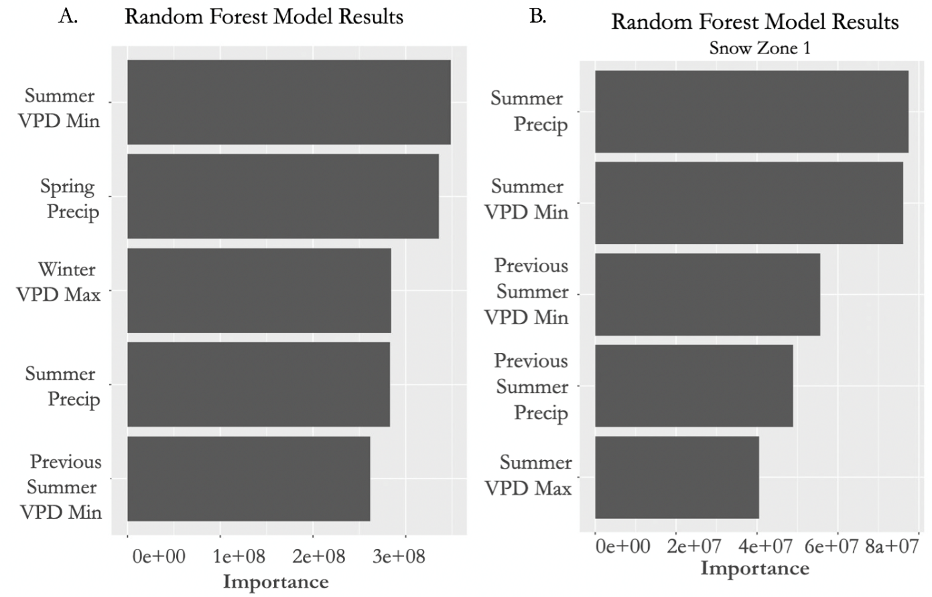

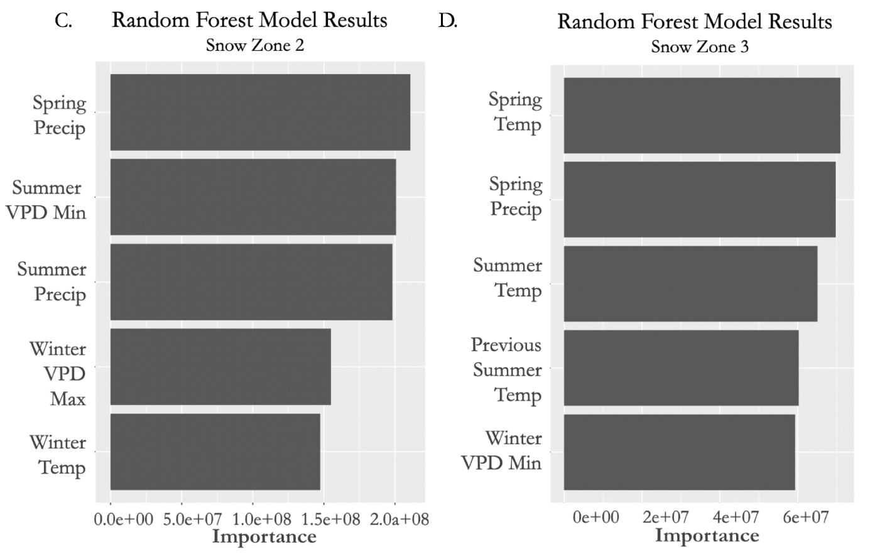

*Figure 4.* Ranked importance of climate variables from the phase 2 random forest model for all snow zones (A.), low snow zones (B.), intermittent snow zones (C.), and transitional snow zones (D.) using data from 1992-2021, excluding EVT as a categorical variable.

***4.2 Limitations***

Due to lack of in situ data within the persistent snow zone, the project analyzed data from the low, intermittent, and transitional snow zones. While the persistent snow zone encompasses only 15.04% of MLRA-48, it does contain critical snowmelt for lower elevation snow zones and is directly related to production downstream. Additional uncertainty may be found in the timing of downloaded snow zone data. Our study area was mapped using snow zone data between 2001-2020, though our analysis includes climate data from as far back as 1984. We assumed that any difference in the spatial distribution of snow zones before 2001 was negligible. Due to the unavailability of RAP data for 2022, we were unable to evaluate the precision of in situ 2022 Eagle Point herbaceous production data. Overall, the study lacked consistent in situ biomass clipping data for both herbaceous and total production rangeland biomass, particularly within the low and persistent snow zones. This limits the performance of the validation study within these models. Many of the in situ data were sampled in mixed forest cover types and were filtered out to avoid using forested data points. This further constrained the number of samples, likely decreasing the performance of our model, particularly within the transitional snow zone. Given the tendency of RAP to overpredict across all snow zones, there is some inherent uncertainty in its accuracy in our phase 2 analysis. Though we believe that its ability to capture overall trends in production will still allow for significance in our evaluation of the connection of early warning climate indicators to rangeland production within MLRA-48.

# 5. Conclusions

In this study, we validated the efficacy of two remotely sensed rangeland production data sets and developed a climate model to assess seasonal climatic controls of forage production across the Southern Rocky Mountain range. This study tailored our analysis to MLRA-48, which hosts a variety of landscapes and ecosystems across a wide range of altitudes. Delineating by snow zone allowed the team to sharpen our analysis and account for some of this variability. We found that the Rangeland Analysis Platform was more successful at estimating in situ biomass than the Rangeland Production Monitoring Service and presented a tendency to overpredict the amount of forage present at each site. Though we believe further validation including additional in situ data across other ecoregions is necessary before confirming the reliability of both platforms. Having evaluated both platforms, our study selected RAP herbaceous biomass data to use in our climate analysis. Using random forest modeling, we ranked seasonal climate variables in order of their ability to successfully predict biomass across MLRA-48. Our model indicated that spring and winter variables, particularly precipitation and vapor pressure deficit were most successful in predicting biomass across all snow zones. We did not find fall variables ranked across any model or snow zone. The inclusion of EVT sharpened the model and confirmed that vegetation type was important in determining biomass. We believe our partners, ranch owners, and land managers can consider these climate indicators when attempting to understand and potentially predict the behavior of rangeland biomass within this ecoregion. As drought conditions progress, it is critical that research on rangelands continues to keep pace with the changing climate and seeks to protect an indispensable industry and ecosystem.

***5.1 Future Work***

While our validation study did yield important insights into the accuracy of RAP and RPMS data, an expansion of in situ clipping data spatially and temporally would allow for additional accuracy in future validation regressions. Our analysis can also be expanded with the addition of 2022 RAP data, which were not available for either phase of our study but is slated to be released later in 2023. Further analysis aiming to understand climate indicators of rangeland production could benefit from including larger global climate phenomena such as the Pacific Decadal Oscillation (PDO) and El Niño/La Niña Southern Oscillation (ENSO), which have been shown to influence forage production in surrounding MLRAs (Raynor 2020). Future work could also consider upland snowfall and seasonal streamflow, which would allow for better understanding of the larger watershed system in determining rangeland biomass. To better understand rangeland production, it may be beneficial to consider climate variables such as snowfall, depth, and seasonal persistence in the persistent snow zone, where upland climate may be influencing lower elevation production. Phase 2 analysis could also be expanded temporally by incorporating climate data from previous years, as there is climate data available dating back to 1986. Additionally, future work could expand upon the climate model that included EVT as a categorical variable and run random forest models for specific vegetation cover types. This would explore how different EVTs respond to variable climate and inform understanding of this MLRA's response to variable climate. Finally, while our model was able to identify which variables have ranked importance in influencing a summer of range production, we did not characterize the correlation or significance of these relationships. It would be beneficial to regress these variables with range production to better understand these relationships and better inform management decisions.

# 6. Acknowledgments

Project Partners:

* Retta Bruegger (Colorado State University Extension)
* Lydia Labelle de Rios (USDA Forest Service)
* Kristy Wallner (Bureau of Land Management, Colorado River Valley Field Office)
* Tonya Haigh (National Drought Mitigation Center)
* Grace Campbell (National Drought Mitigation Center)

Special Thanks:

* Dr. Anthony Vorster (Colorado State University, Natural Resource Ecology Laboratory)
* Sarah Hettema (Colorado Node Fellow)
* Dr. Paul Evangelista (Colorado State University, Natural Resource Ecology Laboratory)
* Dr. Catherine Jarnevich (USGS, Fort Collins Science Center)
* Nicholas Young (Colorado State University, Natural Resource Ecology Laboratory)
* Chris Choi (Colorado State University, Natural Resource Ecology Laboratory)

Any opinions, findings, and conclusions or recommendations expressed in this material are those of the author(s) and do not necessarily reflect the views of the National Aeronautics and Space Administration.

This material is based upon work supported by NASA through contract NNL16AA05C.

# 7. Glossary

**Biomass** - the total quantity or volume of organisms in a given area

**El Niño/La Niña Southern Oscillation (ENSO)** - naturally occurring, irregular variation in wind and sea surface temperatures over the Pacific Ocean. The cooling phase is known as La Niña while the warming phase is known as El Niño

**Existing Vegetation Type (EVT)** - a LANDFIRE data set that classifies vegetation into categories based on their spectral characteristics

**Forage** - plant material available for consumption by livestock

**Forage production** - amount of plant biomass available and consumable by livestock

**Forb** - a dicot without a woody stem, herbaceous flowering plant, excludes grasses

**Google Earth Engine (GEE)** - a free, cloud-based geospatial analysis platform that allows users to access planetary scale spatial analysis using JavaScript based coding

**Herbaceous aboveground biomass** - volume of forbs and grasses in a given area

snow zone- an area characterized by percentage of annual snow persistence

**LANDFIRE** - Landscape Fire and Resource Management Planning Tools, is a shared program between the wildland fire management programs of the U.S. Department of Agriculture Forest Service and U.S. Department of the Interior, providing landscape scale geo-spatial products to support cross-boundary planning, management, and operations

**Major Land Resource Area (MLRA)** - land units delineated by the Natural Resources Conservation Service based on water, vegetation, soil, climate, and land uses

**Normalized Difference Vegetation Index (NDVI)** - the remotely sensed difference between infrared and near infrared light to quantify photosynthetic activity and estimate vegetation, accessible via Landsat 4-9

**National Land Cover Database (NLCD)** - land cover and land use data products created for all 50 states and Puerto Rico in conjunction with the Multi-Resolution Land Characteristics Consortium (MRLC).

**Pacific decadal oscillation (PDO)** - a returning, long-term fluctuation of ocean and atmosphere variability over the Pacific basin that waxes and wanes between 20 to 30 years

**Rangeland production**- total plant biomass grown on rangelands

**Rangeland Analysis Platform (RAP)** - a user-friendly interface for downloading and displaying biomass and vegetation cover data sets derived from the NASA Landsat satellite suite.

**Rangeland Productivity Monitoring Service (RPMS)** - provides remotely sensed estimates of total rangeland biomass, which includes grasses, forbs, shrubs, and trees

**Vapor pressure deficit** - the difference between the amount of moisture currently in the air and the moisture in the air when saturated

# 8. References

Borden, A. (2020, October 9). *Drought conditions continue to grip all of Colorado*. Colorado Public Radio. Retrieved February 8, 2023, from <https://www.cpr.org/2020/10/08/drought-conditions-continue-to-grip-all-of-colorado/>

EOS Project Science Office. (n.d.). *Measuring Vegetation (NDVI&EVI)*. NASA Earth Observatory. Retrieved February 8, 2023, from <https://earthobservatory.nasa.gov/features/MeasuringVegetation/measuring_vegetation_2.php#:~:text=NDVI%20is%20calculated%20from%20the,and%20less%20near%2Dinfrared%20light>.

Ford, P. L., Reeves, M. C., & Frid, L. (2019). A tool for projecting rangeland vegetation response to management and climate. *Rangelands*, *41*(1), 49-60. <https://doi.org/10.1016/j.rala.2018.10.010>

Jones, M. O., Robinson, N. P., Naugle, D. E., Maestas, J. D., Reeves, M. C., Lankston, R. W., & Allred, B. W. (2021). Annual and 16-day rangeland production estimates for the western United States. *Rangeland Ecology & Management*, *77*, 112-117. <https://doi.org/10.1016/j.rama.2021.04.003>

Jones, M. O., Naugle, D. E., Twidwell, D., Uden, D. R., Maestas, J. D., & Allred, B. W. (2020). Beyond inventories: Emergence of a new era in rangeland monitoring. *Rangeland Ecology & Management*, *73*(5), 577-583. <https://doi.org/10.1016/j.rama.2020.06.009>

NRCS, USDA 2015. The National Resources Inventory Grazing Lands On-Site Database. (2015) Compiled by the Resource Inventory Division; processed by the Resource Assessment Division, Conservation Effects Assessment Project—Grazing Land Component.

Rangeland Analysis Platform. (2023). *Processing RAP data in Google Earth Engine.* Rangeland Analysis Program. <https://rangelands.app/support/article/61-processing-rap-data-in-google-earth-engine>

Raynor, E. J., Derner, J. D., Hoover, D. L., Parton, W. J., & Augustine, D. J. (2020). Large‐scale and local climatic controls on large herbivore productivity: implications for adaptive rangeland management. Ecological Applications, 30(3), e02053. <https://doi.org/10.1002/eap.2053>

Reeves, M. C., & Lankston, R. (n.d.). Download Fuelcast and RPMS. Fuelcast. Retrieved March 1, 2023, from <https://www.fuelcast.net/downloads>

Reeves, M. C., Hanberry, B. B., Wilmer, H., Kaplan, N. E., & Lauenroth, W. K. (2021). An assessment of production trends on the Great Plains from 1984 to 2017. *Rangeland Ecology & Management*, *78*, 165-179. https://doi.org/10.1016/j.rama.2020.01.011

Smith, W. K., Dannenberg, M. P., Yan, D., Herrmann, S., Barnes, M. L., Barron-Gafford, G. A., ... & Yang, J. (2019). Remote sensing of dryland ecosystem structure and function: Progress, challenges, and opportunities. *Remote Sensing of Environment*, *233*, 111401. https://doi.org/10.1016/j.rse.2019.111401

Soil Survey Staff, 2017. Natural Resources Conservation Service. (2017). US Department of Agriculture. Web soil survey, Washington, DC, USA.

United States Drought Monitoring Service. (2020). *US Drought Monitor: Colorado.*

Wickham, H. (2016). ggplot2: Elegant Graphics for Data Analysis. Springer-Verlag New York. ISBN 978-3- 319-24277-4, <https://ggplot2.tidyverse.org>

Wickham H, François R, Henry L, Müller K, Vaughan D (2023). dplyr: A Grammar of Data Manipulation. https://dplyr.tidyverse.org, <https://github.com/tidyverse/dplyr>.

Wright MN, Ziegler A (2017). “ranger: A Fast Implementation of Random Forests for High Dimensional Data in C++ and R.” Journal of Statistical Software, 77(1), 1–17. <https://doi.org/10.18637/jss.v077.i01>

Zhang, F., Biederman, J. A., Dannenberg, M. P., Yan, D., Reed, S. C., & Smith, W. K. (2021). Five decades of observed daily precipitation reveal longer and more variable drought events across much of the western United States. *Geophysical Research Letters*, *48*(7), e2020GL092293. <https://doi.org/10.1029/2020GL092293>

# 9. Appendices

Appendix A. Data Acquisition

Table A1. *Random Forest Variables*

|  |  |  |
| --- | --- | --- |
| **Random Forest Variables** | **Resolution** | **Source** |
| Mean Temperature in Celsius | 4.6 km | PRISM |
| Total Precipitation | 4.6 km | PRISM |
| Mean Snow Water Equivalent (SWE) | 1 km | Daymet |
| Mean Vapor Pressure Deficit Max (VPD) | 4.6 km | PRISM |
| Mean Vapor Pressure Deficit Min (VPD) | 4.6 km | PRISM |
| Mean Wind Velocity | 4.6 km | PRISM |
| Mean Palmer Drought Severity Index (PDSI) | 4.6 km | PRISM |
| Existing Vegetation Type | 30 m | LANDFIRE |
| Herbaceous Above Ground Biomass | 30 m | RAP |

Appendix B. Model Performance

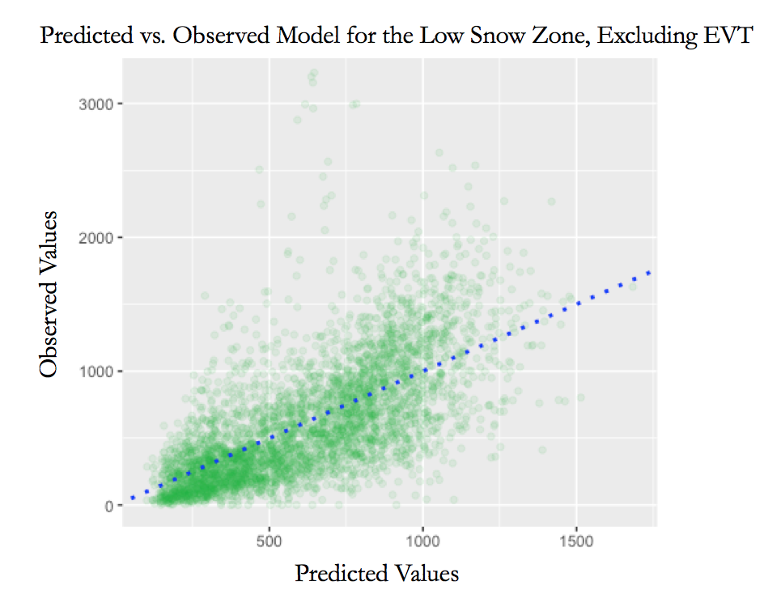

*Figure B1*. Predicted versus observed values of the phase 2 climate model for the low snow zone with a 1:1 line (blue dotted), inclusive of EVT as a categorical variable.

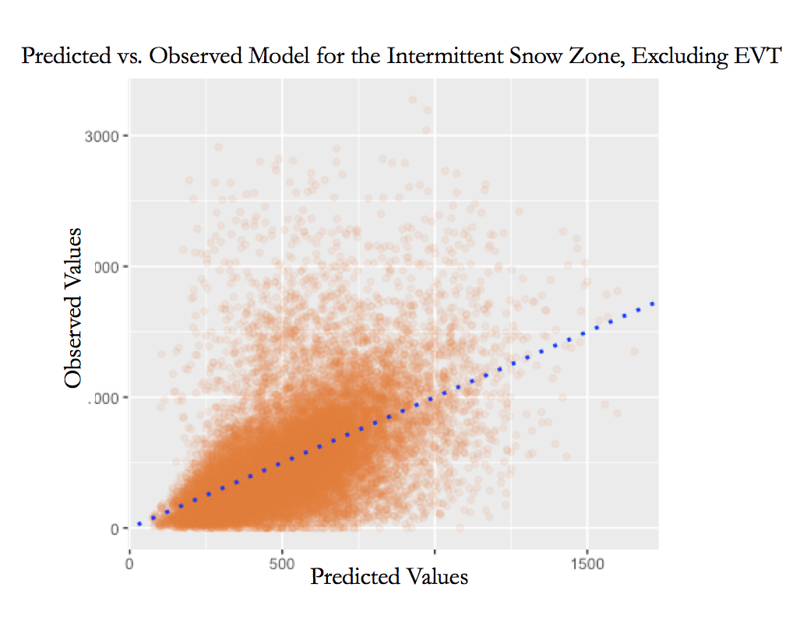

*Figure B2.* Predicted versus observed values of the phase 2 climate model for the intermittent snow zone, with a 1:1 line (blue dotted), inclusive of EVT as a categorical variable.

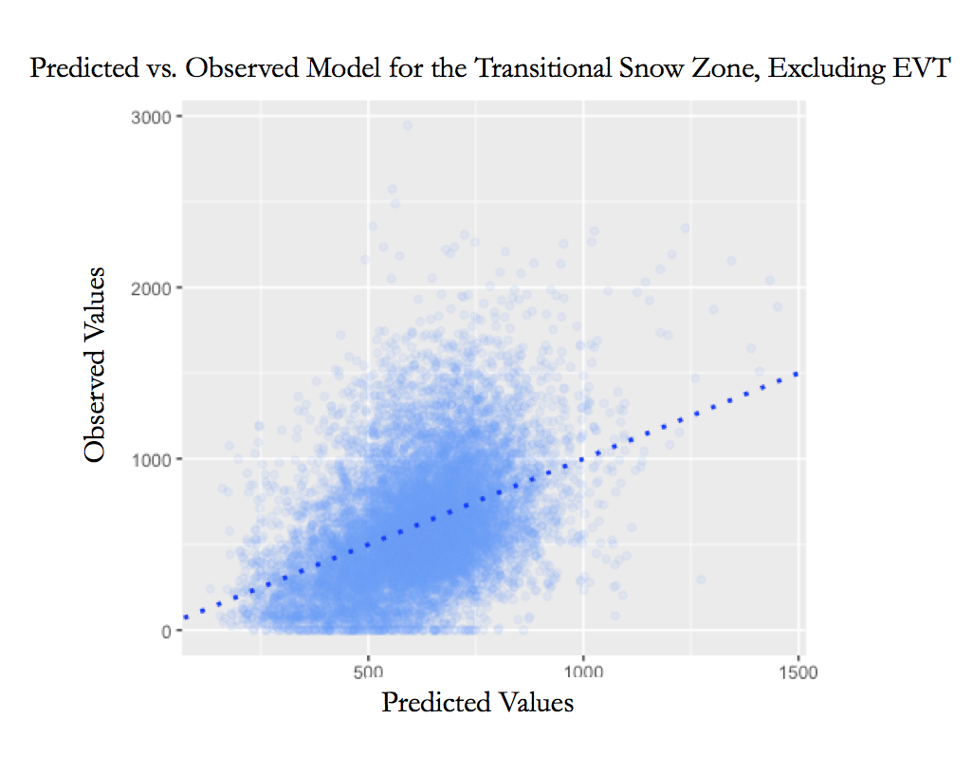

*Figure B3*. Predicted versus observed values of the phase 2 climate model for the transitional snow zone, with a 1:1 line (blue dotted), inclusive of EVT as a categorical variable.

Appendix C. Ranked Climate Variables

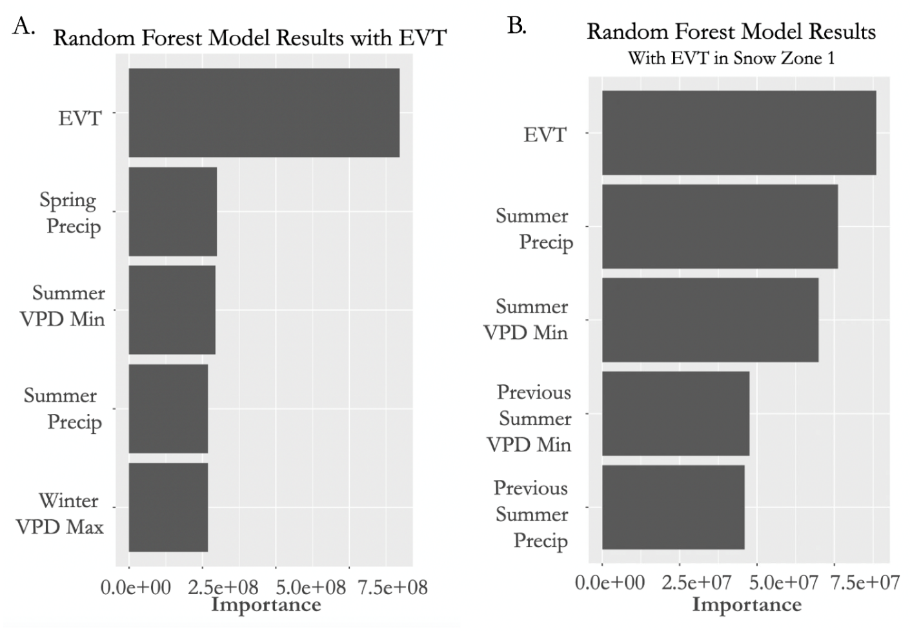

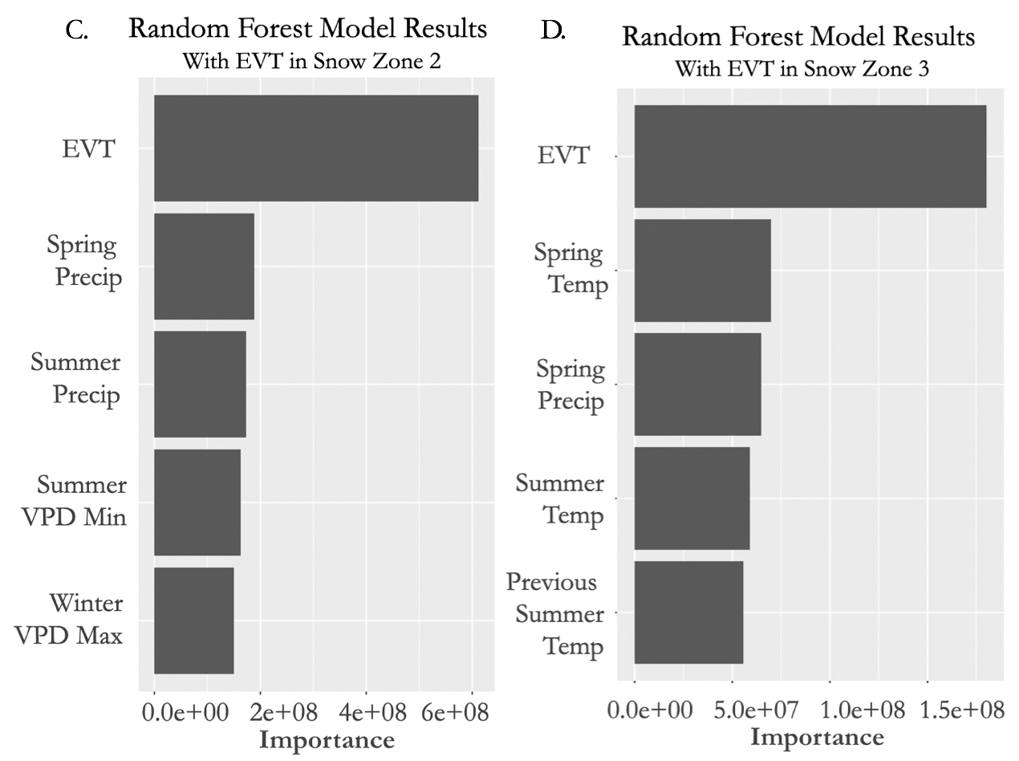

*Figure C1*. Ranked importance of climate variables from the phase 2 random forest model for all snow zones (A.), low (B.), intermittent (C.), transitional (D.) snow zones using data from 1992-2021 including EVT as a categorical variable.